
Market Segmentation Template
Step 1: Brainstorm Broadly Potential Market Segments for Your Idea/Technology/Product


What is my idea or technology?

Access is a platform that provides an accessibility mapping allowing individuals with mobility challenges to easily navigate urban areas. It enables users to report inaccessible sidewalks, view live accessible routes and receive updates about public construction. The platform includes a real-time map, image-based reporting, customizable UI/UX for accessibility and statistics for municipalities. The system consists of one mobile app for users to navigate and report inaccessible pathways, and one web app for municipalities to view statistics and publish scheduled constructions.
What industries and end users could my idea or technology apply to?
Industry or Similar Category | End Users | What They Would Use It For
Local Government | Municipality Staff | Monitor accessibility issues, publish scheduled construction and plan urban improvements
Urban Planning | Engineers, Designers | Analyze user data to design accessible infrastructure and prioritize public constructions
Public | Individuals with Disabilities | Navigate safely through the city, avoid inaccessible areas and submit real-time reports
Local Business | Café, Restaurants, Stores | Promote their business as accessible friendly to attract more customers
Tourists & Travel Agencies | Visitors with Disabilities | Discover accessible pathways and avoid disruptions due to public constructions
Accessibility Advocacy | NPOs, Disability Groups | Use map data to promote inclusive urban design
Smart City/GovTech | Tech Integrators | Integrate ACCESS data into smart infrastructure and dashboards

Step 2: Narrow Down This Broad List of
Potential Market Segments to 6-8

Top target Markets to Consider for My Startup
End user | Target customers well-  funded? | Target  customer  readily  accessible to sales force? | Target  customers’ compelling  reason to buy? | Can you deliver a whole product? | Is there  entrenched competition? | Can you leverage this segment to enter others? | Consistent with values, passions, goals of team? | Rank
Citizens with mobility disabilities | No | High | Yes - safe, accessible navigation(vital) | Yes | Low | Yes | Yes | 1
Municipalities | Yes | Moderate | Yes - need tools for smart urban planning & accessibility compliance | Yes | Low | Yes | Yes | 2
Local Businesses (cafés, stores) | Yes/No | High | Yes - reputation need and accessible environment | Yes | Low | Yes | Yes | 3
Accessibility NPO’s | Yes/No | High | Yes - need data to advocate and act | Yes | Low | Yes | Yes | 4
Urban Planners | Yes | Low | Moderate - depends on city’s budget & policies | No | Moderate | Yes | Yes | 5
Visitors with Disabilities | No | Moderate | Yes - accessible travel experience | Yes | Low | Yes | Yes | 6



Step 3: Drop These Market Segments Into a Matrix and Review/Update the Rows for Your Situation

Market Segmentation Matrix Row Definitions

Market | Public | Local Government | Local Businesses | Accessibility Advocacy | Urban Planning | Tourists & Travel Agencies
End User | Citizens with mobility issues | Municipalities | Cafés, Restaurants, Stores | Accessibility NPO’s | Urban Planners | Visitors with Disabilities
Task | Navigate safely, avoid inaccessible pathways, report obstacles. | Monitor & act on accessibility reports, analyze statistics. | Promote themselves on a bigger platform as accessible and friendly. | Use data to advocate for change. | Design more accessible pathways for every citizen. | Plan accessible routes when visiting cities.
Benefit | Independence, peace of mind, real-time information, safer mobility. | Smart decision-making, compliance, citizen satisfaction | Increased visibility & inclusion | Actionable evidence | Better planning based on real citizen data | Confidence, barrier-free travel experience
Urgency of Need | High | High | Moderate | High | Moderate | Moderate
Example End Users | Wheelchair users, elderly citizens, parents with strollers | Municipality of Chalandri, Municipality of Athens | Restaurants, Cafés | European Disability Forum | Urban design teams, engineers | Travel agencies offering disability friendly routes
Lead Customers | Influencers with disabilities | Municipalities with accessibility goals | Chains supporting inclusivity | Accessibility communities, local disability groups | City infrastructure departments/staff | Accessibility focused tourism providers
Willingness to Change | High | Moderate | Moderate | High | Moderate | High
Frequency of Buying | Rarely - Only for strong personal benefit | Per project - 3+ months | Occasionally - Based on visibility gains | Rarely - Support campaigns | Per project - 3+ months | Rarely - Support campaigns and support accessibility
Concentration of Buyers | Many Competitive buyers | Oligopoly | Many Competitive buyers | Oligopoly | Oligopoly | Many Competitive buyers
Other relevant market  considerations | Highly viral (WOM) among communities with mobility disabilities (growth by social need) | High bureaucracy and long cycles, but public pressure accelerates action | Low margin segment, motivated by social proof or local reputation | Mission-driven, often backed by grants or donor reporting cycles | Project-based cycles, dependent on government fundings | High seasonal variability but strong WOM through influencer reviews
Size of Market (# of end  users) | 4B~5B | 500K~600K | 10M~100M | 50K~200K | 500K~1M | 500K~1M
Est. value of end user ($1,  $10, $100, $1K, etc.) | $0-$10 | $10K-$100K | $100-$1K | $1K-$10K | $5K-$50K | $1K-$10K
Competition/ alternatives | Competitive alternative apps (Wheelmap, Google maps) | Analysts | Google Maps | DIY map | Other analysts that are conducting research and mapping the streets | AccessibleGo, Google Maps
Other components  needed for a full solution | Software for automating the accessibility report system, algorithms for navigation | Public construction management | Accessibility certification, user reviews for accessibility | Advocacy and Awareness campaigns and petitions | Access to crowdsourced data for city planning | Integration with travel APIs
Important partners | Community groups and online forums | Smart City platforms, Governmental construction and infrastructure departments | Business review platforms (Google Maps), Local business associations | Disability Advocacy organizations, universities, volunteer networks (ABC genZ) | Municipal planning departments, City planning software providers (ArcGIS) | Accessible tourism initiatives and agencies
Other relevant personal  considerations | Deeply passionate about inclusion and accessibility and personal drive to impact lives, any urban areas with accessibility challenges, disability rights advocates | Experience with civil tech and knows how public procurement works, prioritizing smart city and inclusivity initiatives | Tourist-heavy districts, city centers, social responsibility | Passion for advocacy and equity | Background in urban studies, smart city projects, architecture firms | Strategic location advantage and personal experiences with inaccessible travel inspires the vision

Calculate the TAM for the beachhead market
TAM is the “pie in the sky” number. It represents the absolute maximum possible revenue that a business could generate in the market, if every single potential customer is converted into a paying customer, and each of those customers is providing the full maximum revenue.
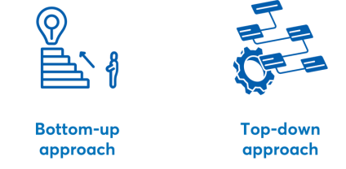


Bottom-Up TAM Analysis
Summary

I. | One Time Charge Data Point
Ia | Estimation of price per unit | 1000$ (all except public users)
Ib | Number of units needed per end user | 1
Ic | Average life of product in years | 2
Id | Annualized revenue(Ia*Ib)/Id (Data Point I) | 500$
2. | Budget Available Data Points
a | Current spending per end user (Data point 2) | 200.000$
2b | Total budget for the end user | 1.000.000$
2c | What percentage of the budget could go to this solution reasonably? | 15%
2d | Annualize revenue (2b*2c) (Data Point 3) | 150.000$
3. | Comparables
3a | Who are the comparables for your business? | Social Impact, Coloplast, Citymapper Ltd
3b | What are the comparable products? | Wheelmap, Wheelmate, Citymapper
3c | What is the comparable converted to similar annualized revenue  (Data Point 4 plus however many more you deem relevant)? | 100M
4. | Interpreting the Results
4a | Consensus on estimate of annualized revenue per end user, based on the four Data Points above (range is fine) | $15,000 – $60,000
 | How did you end up at this number/range? | Since ACCESS offers a more tailored solution (real-time accessibility mapping, AI-powered reporting, city dashboards), the pricing aligns with $15,000–$60,000 per end user annually.

Top-Down TAM Analysis
Summary

 | Title | Estimation | Source/ based on:
1 | Total # of end users in the broad market segment | ~1B | Estimated based on people with mobility disabilities worldwide (~4.2B disabled people, ~20% with mobility challenges), municipalities, urban planners, accessibility NPOs, businesses (restaurants, cafes, hotels, travel agencies), and tourists.
2 | Total # of end users in the targeted subsegment of your Beachhead Market | 50.000 - 200.000 | Focused on municipalities, urban planners, accessibility organizations, and businesses in top cities where accessibility improvements are actively pursued.
3 | Annual monetizable revenue per user | 15.000$ - 65.000$ | Based on budget allocation estimates (10–40% of accessibility budgets), comparable SaaS models (Mapbox, ArcGIS, Wheelmap), and per-user spending trends.
4 | Estimate of top-down TAM (line 2 times line 3) | 750K - 130M | (50,000 users × $5,000) to (200,000 users × $20,000) → Shows total potential revenue in Beachhead Market.
5 | Estimate of range of profitability for your product | 20%-50%  EBITDA margin | Based on SaaS industry benchmarks, GIS and smart mobility software margins, and accessibility-focused platforms. High scalability and low marginal costs make profitability attractive.
6 | Estimated Compound Annual Growth Rate (CAGR) | 15% – 30% | Accessibility tech and smart city industries are growing rapidly. Estimated based on growth rates from GIS software (~12%), urban mobility (~20%), and accessibility technology (~25%).
7 | Estimated time to achieve 20 percent market share | 2-3 years | Based on SaaS adoption cycles, government procurement processes, and municipal policy changes.
8 | Anticipated market share if you are reasonably successful | 30% – 50% of target market | If ACCESS becomes a leader in accessibility mapping and municipal integrations, it can capture a dominant market position in its niche.
 | What are the three top assumptions that could affect the attractiveness of the Beachhead Market for your product (besides the product itself)? | 1. Government and municipal adoption rate  - If municipalities and urban planners slowly adopt accessibility solutions, growth could be hindered.  - Mitigation: Build strategic partnerships with governments and NGOs.  2. User engagement and crowdsourced data contribution  - The value of ACCESS depends on real-time, accurate reporting.  - Mitigation: Incentivize contributions via gamification, rewards, and AI automation for data collection.  3. Competitive response from large mapping companies  - Companies like Google Maps or Apple Maps could improve their accessibility features, reducing demand for standalone solutions.  - Mitigation: Focus on hyper-local, real-time updates and partnerships with disability advocacy groups.




Competition Analysis
A competition analysis plays an important role. Making a competition
analysis to know enough about competitors is very important for business. By doing the analysis, you will identify the strengths and weaknesses of current and potential competitors and establish what makes your product or service unique, so that you can develop the correct strategy to win the battle. Here are 4 charts business people often use when doing a competitor analysis.

Chart 1: Competitive Positioning
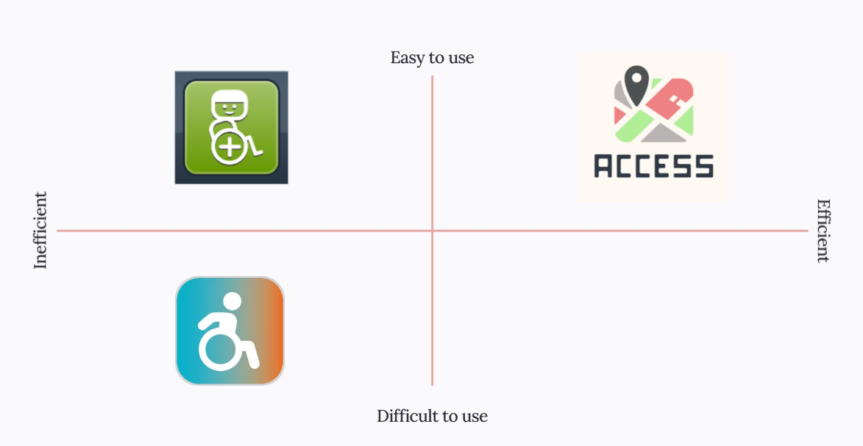


Chart 2: Comparison Table

Χαρακτηριστικά | WheelMap | ACCESS
Φιλικές επιχειρήσεις / υπηρεσίες | ✅ | ✅
Προσθήκη Φωτογραφιών | ✅ | ✅
Εφαρμογή Φίλτρων Προσβάσιμων Επιχειρήσεων | ✅ | ✅
Οργάνωση Ομαδικής Χαρτογράφησης Καταστημάτων | ✅ | ❌
Αναφορά Χρηστών για φιλικές επιχειρήσεις υπηρεσίες | ✅ | ✅
Αναφορά Χρηστών για φιλικές διαδρομές | ❌ | ✅
Προσαρμόσιμο UI | ❌ | ✅
Φωνητικές Εντολές | ❌ | ✅
Δυναμική Χαρτογράφηση Προσβάσιμων Διαδρομών | ❌ | ✅
Αναφορές Προβλημάτων για τις Δημόσιες Αρχές | ❌ | ✅
Ζωντανές Ειδοποιήσεις αλλαγών στις υποδομές | ❌ | ✅
Διασύνδεση με δημόσιους φορείς | ❌ | ✅
web version για διεπαφή Δήμου. | ❌ | ✅


